<4-3 XML>

<?xml version="1.0" encoding="utf-8"?>  
<LinearLayout xmlns:android="http://schemas.android.com/apk/res/android"  
 xmlns:tools="http://schemas.android.com/tools"  
 android:layout_width="match_parent"  
 android:layout_height="match_parent"  
 tools:context=".MainActivity"  
 android:orientation="vertical">  
  
 <EditText  
 android:layout_width="wrap_content"  
 android:layout_height="wrap_content"  
 android:id="@+id/editNum1"  
 android:layout_margin="10dp"  
 android:hint="숫자1"/>  
 <EditText  
 android:layout_width="wrap_content"  
 android:layout_height="wrap_content"  
 android:id="@+id/editNum2"  
 android:layout_margin="10dp"  
 android:hint="숫자2"/>  
 <Button  
 android:layout_width="match_parent"  
 android:layout_height="wrap_content"  
 android:id="@+id/btnAdd"  
 android:backgroundTint="#D5D5D5"  
 android:textColor="#000000"  
 android:layout_margin="10dp"  
 android:text="더하기"/>  
 <Button  
 android:layout_width="match_parent"  
 android:layout_height="wrap_content"  
 android:id="@+id/btnSub"  
 android:backgroundTint="#D5D5D5"  
 android:textColor="#000000"  
 android:layout_margin="10dp"  
 android:text="빼기"/>  
 <Button  
 android:layout_width="match_parent"  
 android:layout_height="wrap_content"  
 android:id="@+id/btnMul"  
 android:layout_margin="10dp"  
 android:backgroundTint="#D5D5D5"  
 android:textColor="#000000"  
 android:text="곱하기"/>  
 <Button  
 android:layout_width="match_parent"  
 android:layout_height="wrap_content"  
 android:id="@+id/btnDiv"  
 android:layout_margin="5dp"  
 android:backgroundTint="#D5D5D5"  
 android:textColor="#000000"  
 android:text="나누기"/>  
  
 <Button  
 android:layout_width="match_parent"  
 android:layout_height="wrap_content"  
 android:id="@+id/btnRest"  
 android:layout_margin="10dp"  
 android:backgroundTint="#D5D5D5"  
 android:textColor="#000000"  
 android:text="나머지값"/>  
 <TextView  
 android:layout_width="wrap_content"  
 android:layout_height="wrap_content"  
 android:id="@+id/tvResult"  
 android:textSize="30dp"  
 android:textColor="#FF0000"  
 android:layout_margin="10dp"  
 android:text="계산 결과 : " />  
  
</LinearLayout>

<4-3 JAVA>

package com.example.a36assis4_3;  
  
import androidx.appcompat.app.AppCompatActivity;  
import android.os.Bundle;  
import android.view.View;  
import android.widget.Button;  
import android.widget.EditText;  
import android.widget.TextView;  
import android.widget.Toast;  
  
public class MainActivity extends AppCompatActivity {  
 EditText editNum1, editNum2;  
 Button btnAdd, btnSub, btnMul, btnDiv, btnRest;  
 TextView tvResult;  
  
 @Override  
 protected void onCreate(Bundle savedInstanceState) {  
 super.onCreate(savedInstanceState);  
 setContentView(R.layout.*activity_main*);  
  
 editNum1 = findViewById(R.id.*editNum1*);  
 editNum2 = findViewById(R.id.*editNum2*);  
 btnAdd = findViewById(R.id.*btnAdd*);  
 btnSub = findViewById(R.id.*btnSub*);  
 btnMul = findViewById(R.id.*btnMul*);  
 btnDiv = findViewById(R.id.*btnDiv*);  
 btnRest = findViewById(R.id.*btnRest*);  
 tvResult = findViewById(R.id.*tvResult*);  
  
  
 btnAdd.setOnClickListener(new View.OnClickListener() {  
 public void onClick(View v) {  
 String num1Str = editNum1.getText().toString();  
 String num2Str = editNum2.getText().toString();  
  
 if (num1Str.trim().equals("") || num2Str.trim().equals("")) {  
 Toast.*makeText*(getApplicationContext(), "입력 값이 비었습니다.", Toast.*LENGTH_SHORT*).show();  
 } else {  
 double result = Double.*parseDouble*(num1Str) + Double.*parseDouble*(num2Str);  
 tvResult.setText("계산 결과 : " + result);  
 }  
 }  
 });  
  
 btnSub.setOnClickListener(new View.OnClickListener() {  
 public void onClick(View v) {  
 String num1Str = editNum1.getText().toString();  
 String num2Str = editNum2.getText().toString();  
  
 if (num1Str.trim().equals("") || num2Str.trim().equals("")) {  
 Toast.*makeText*(getApplicationContext(), "입력 값이 비었습니다.", Toast.*LENGTH_SHORT*).show();  
 } else {  
 double result = Double.*parseDouble*(num1Str) - Double.*parseDouble*(num2Str);  
 tvResult.setText("계산 결과 : " + result);  
 }  
 }  
 });  
  
 btnMul.setOnClickListener(new View.OnClickListener() {  
 public void onClick(View v) {  
 String num1Str = editNum1.getText().toString();  
 String num2Str = editNum2.getText().toString();  
  
 if (num1Str.trim().equals("") || num2Str.trim().equals("")) {  
 Toast.*makeText*(getApplicationContext(), "입력 값이 비었습니다.", Toast.*LENGTH_SHORT*).show();  
 } else {  
 double result = Double.*parseDouble*(num1Str) * Double.*parseDouble*(num2Str);  
 tvResult.setText("계산 결과 : " + result);  
 }  
 }  
 });  
  
 btnDiv.setOnClickListener(new View.OnClickListener() {  
 public void onClick(View v) {  
 String num1Str = editNum1.getText().toString();  
 String num2Str = editNum2.getText().toString();  
  
 if (num1Str.trim().equals("") || num2Str.trim().equals("")) {  
 Toast.*makeText*(getApplicationContext(), "입력 값이 비었습니다.", Toast.*LENGTH_SHORT*).show();  
 } else {  
 if (Double.*parseDouble*(num2Str) == 0) {  
 Toast.*makeText*(getApplicationContext(), "0으로 나눌 수 없습니다.", Toast.*LENGTH_SHORT*).show();  
 } else {  
 double result = Double.*parseDouble*(num1Str) / Double.*parseDouble*(num2Str);  
 tvResult.setText("계산 결과 : " + result);  
 }  
 }  
 }  
 });  
  
  
 btnRest.setOnClickListener(new View.OnClickListener() {  
 public void onClick(View v) {  
 String num1Str = editNum1.getText().toString();  
 String num2Str = editNum2.getText().toString();  
  
 if (num1Str.trim().equals("") || num2Str.trim().equals("")) {  
 Toast.*makeText*(getApplicationContext(), "입력 값이 비었습니다.", Toast.*LENGTH_SHORT*).show();  
 } else {  
 double result = Double.*parseDouble*(num1Str) % Double.*parseDouble*(num2Str);  
 tvResult.setText("계산 결과 : " + result);  
 }  
 }  
 });  
  
  
 }  
}

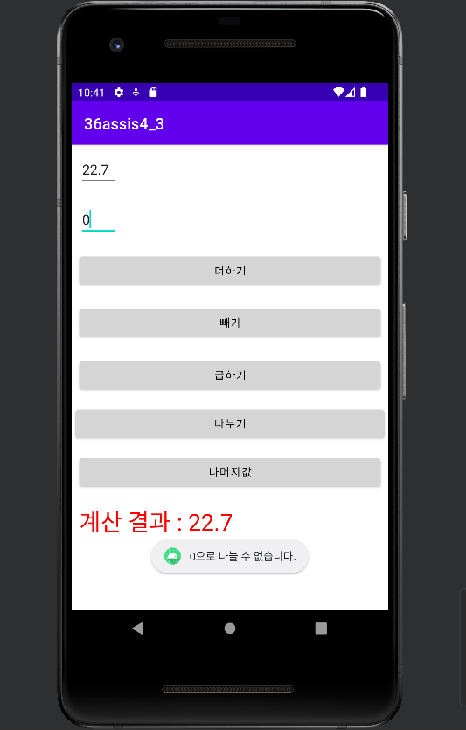

<4-4 XML>

<?xml version="1.0" encoding="utf-8"?>  
<LinearLayout xmlns:android="http://schemas.android.com/apk/res/android"  
 xmlns:app="http://schemas.android.com/apk/res-auto"  
 xmlns:tools="http://schemas.android.com/tools"  
 android:layout_width="match_parent"  
 android:layout_height="match_parent"  
 tools:context=".MainActivity"  
 android:orientation="vertical"  
 android:padding="20dp">  
  
 <TextView  
 android:layout_width="wrap_content"  
 android:layout_height="wrap_content"  
 android:text="선택을 시작하겠습니까?"  
 />  
 <Switch  
 android:layout_width="wrap_content"  
 android:layout_height="wrap_content"  
 android:text="시작함"  
 android:id="@+id/startSwitch"  
 />  
 <TextView  
 android:layout_width="wrap_content"  
 android:layout_height="wrap_content"  
 android:visibility="invisible"  
 android:id="@+id/like"  
 android:text="좋아하는 안드로이드 버전은?"  
 />  
  
 <RadioGroup  
 android:layout_width="wrap_content"  
 android:layout_height="wrap_content"  
 android:id="@+id/androidgroup"  
 android:visibility="invisible">  
 <RadioButton  
 android:layout_width="wrap_content"  
 android:layout_height="wrap_content"  
 android:text="Q(9.0)"  
 android:id="@+id/Q"/>  
 <RadioButton  
 android:layout_width="wrap_content"  
 android:layout_height="wrap_content"  
 android:text="R(10.0)"  
 android:id="@+id/R"/>  
 <RadioButton  
 android:layout_width="wrap_content"  
 android:layout_height="wrap_content"  
 android:text="S(11.0)"  
 android:id="@+id/S"/>  
 </RadioGroup>  
  
 <ImageView  
 android:layout_width="100dp"  
 android:layout_height="100dp"  
 android:id="@+id/img"  
 android:visibility="invisible"  
 />  
  
 <Button  
 android:layout_width="wrap_content"  
 android:layout_height="wrap_content"  
 android:text="종료"  
 android:id="@+id/exit"/>  
 <Button  
 android:layout_width="wrap_content"  
 android:layout_height="wrap_content"  
 android:text="처음으로"  
 android:id="@+id/initial"/>  
</LinearLayout>

<4-4 JAVA>  
package com.example.a36assis4_4;  
  
import androidx.appcompat.app.AppCompatActivity;  
  
import android.os.Bundle;  
import android.view.View;  
import android.widget.Button;  
import android.widget.CompoundButton;  
import android.widget.ImageView;  
import android.widget.RadioButton;  
import android.widget.RadioGroup;  
import android.widget.Switch;  
import android.widget.TextView;  
import android.widget.Toast;  
  
import org.w3c.dom.Text;  
  
public class MainActivity extends AppCompatActivity {  
 private Switch startswitch;  
 private RadioButton QQ,RR,SS;  
 private RadioGroup androidgroup;  
 private Button exit,initial;  
 private TextView like;  
 private ImageView img;  
 @Override  
 protected void onCreate(Bundle savedInstanceState) {  
 super.onCreate(savedInstanceState);  
 setContentView(R.layout.*activity_main*);  
 setTitle("안드로이드 사진 보기");  
  
 androidgroup = (RadioGroup) findViewById(R.id.*androidgroup*);  
 startswitch = (Switch) findViewById(R.id.*startSwitch*);  
 QQ = (RadioButton) findViewById(R.id.*Q*);  
 RR = (RadioButton) findViewById(R.id.*R*);  
 SS = (RadioButton) findViewById(R.id.*S*);  
 like = (TextView) findViewById(R.id.*like*);  
 exit = (Button) findViewById(R.id.*exit*);  
 initial = (Button) findViewById(R.id.*initial*);  
 img = (ImageView) findViewById(R.id.*img*);  
  
  
 startswitch.setOnCheckedChangeListener(new CompoundButton.OnCheckedChangeListener() {  
 @Override  
 public void onCheckedChanged(CompoundButton buttonView, boolean isChecked) {  
 if(isChecked == true){  
 androidgroup.setVisibility(View.*VISIBLE*);  
 like.setVisibility(View.*VISIBLE*);  
 img.setVisibility(View.*VISIBLE*);  
 exit.setVisibility(View.*VISIBLE*);  
 initial.setVisibility(View.*VISIBLE*);  
 }  
 else{  
 androidgroup.setVisibility(View.*INVISIBLE*);  
 like.setVisibility(View.*INVISIBLE*);  
 img.setVisibility(View.*INVISIBLE*);  
 exit.setVisibility(View.*INVISIBLE*);  
 initial.setVisibility(View.*INVISIBLE*);  
 }  
 }  
 });  
 androidgroup.setOnCheckedChangeListener(new RadioGroup.OnCheckedChangeListener() {  
 @Override  
 public void onCheckedChanged(RadioGroup group, int checkedId) {  
 switch(androidgroup.getCheckedRadioButtonId()){  
 case R.id.*Q*:  
 img.setImageResource(R.drawable.*cat*);  
 break;  
 case R.id.*R*:  
 img.setImageResource(R.drawable.*dog*);  
 break;  
 case R.id.*S*:  
 img.setImageResource(R.drawable.*rabbit*);  
 break;  
 }  
 }  
 });  
  
  
 exit.setOnClickListener(new View.OnClickListener() {  
 @Override  
 public void onClick(View v) {  
 finish();  
 }  
 });  
  
 initial.setOnClickListener(new View.OnClickListener() {  
 @Override  
 public void onClick(View v) {  
 startswitch.setChecked(false);  
 androidgroup.setVisibility(View.*INVISIBLE*);  
 like.setVisibility(View.*INVISIBLE*);  
 QQ.setChecked(false);  
 RR.setChecked(false);  
 SS.setChecked(false);  
 }  
 });  
 }  
}

